65 Data structure and d3 nests

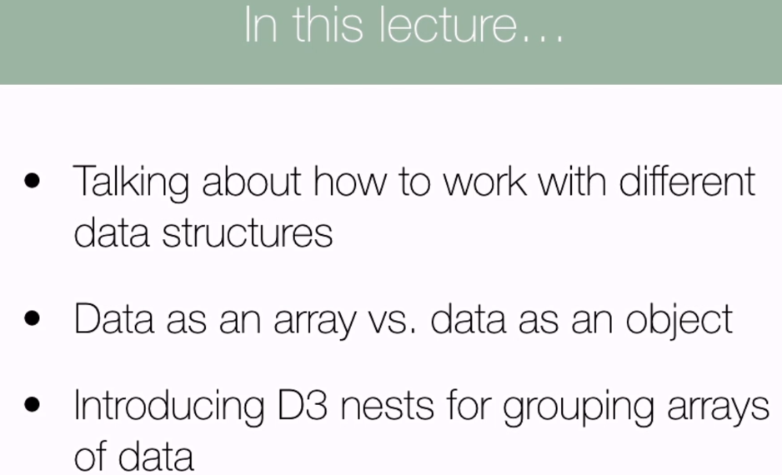 

Putting data in to the right structure to begin with improves performance

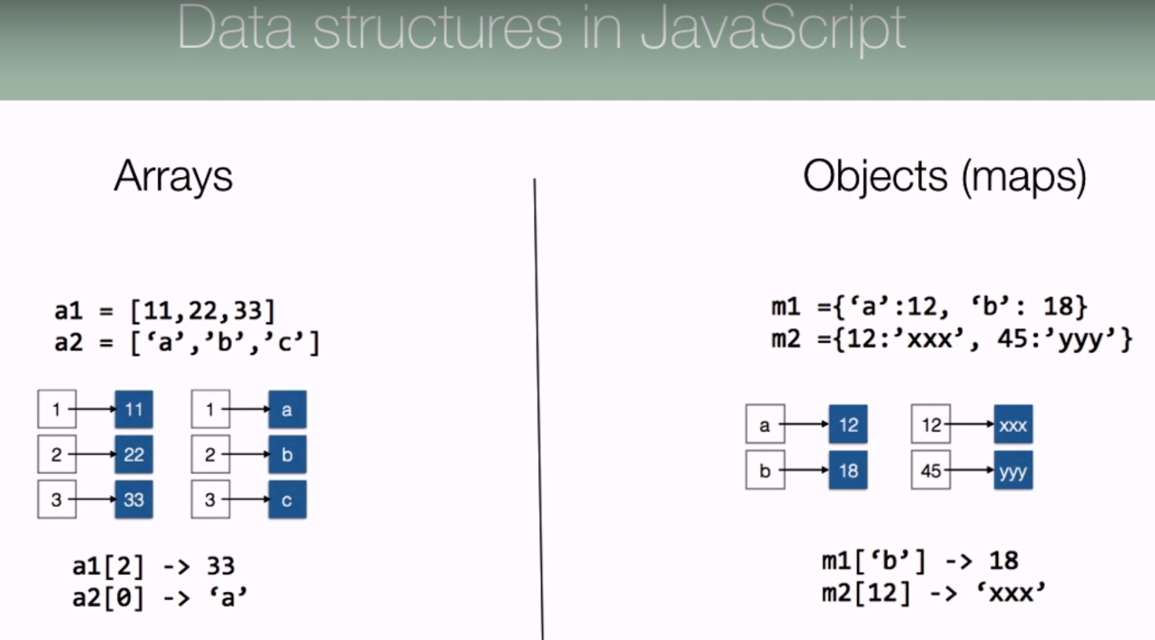

Arrays of objects are common a brute force search can take time

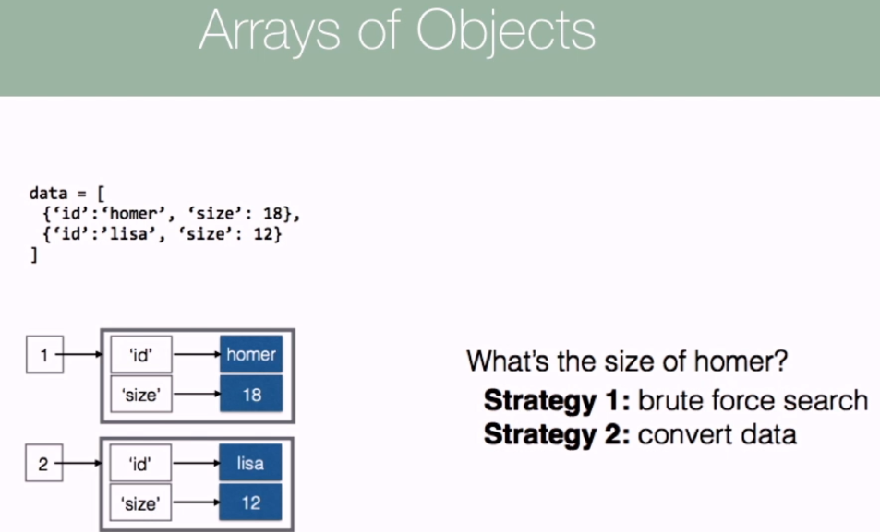

More elegant to convert data into a different format.

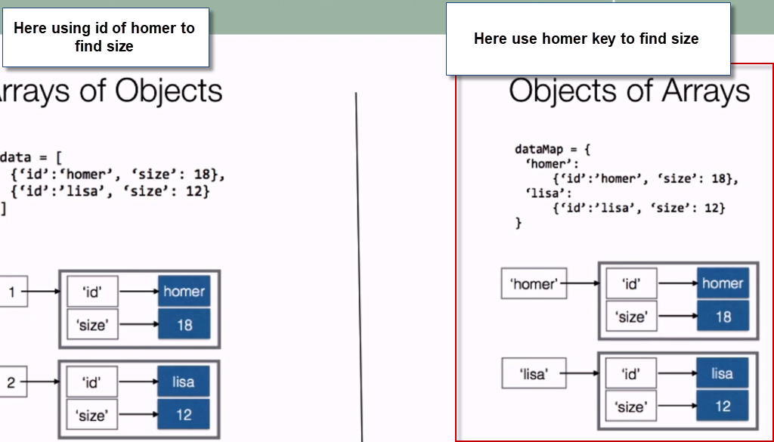

D3 Nest function allows us to group rows of data according to different keys.

Barley yields read in from CSV file – chart to compare yields of different varieties of barley

Would need to loop over the yields array to do this

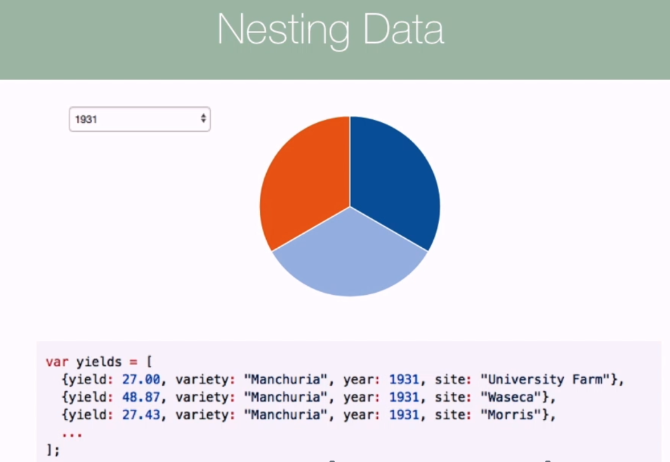

D3.nest()

Provide it with an access function using the key method which will point nest to values that it should be grouping by. If more than one key provided will group by more than one category.

.entries() method gets the array we want to pass to the nest()

